COVID-19

Abstract— the deadly corona virus is spreading all around the world at a very faster rate and is impacting global health and economy very badly. This virus first occurs in the Wuhan estate of china and the mortality rate of this virus is increasing day by day .This disease has a lot of symptoms like throat infection, cold, cough and fever but it mostly effects the lungs and being inside the body, we have to do X-ray or follow any other methodology to detect the virus. There are a lot of kits like RT-PCR but they are not 100 percent accurate and can give false information .Hence we have taken the help of deep learning to detect the patients infected from this disease. This technology is helpful for both patients and doctors and can help the country saving a lot of capital. This image based approach is reliable and the accuracy is also high. A lot of research has been done in the clinical research and many predictive techniques have been applied in clinical decision making like predicting occurrence of a disease or diagnosis or making predictions about new stains of virus etc. This report represents the application of deep learning models and we tried to a train a CNN to detect the corona-virus and with these models we have obtained an accuracy score of around 92 percent.

Introduction
At the beginning of 2020 human kind faced a pandemic known as SARS CoV-2 or Corona virus. This disease has become a serious threat to the entire population of world and raised a question to the current medical health care and awareness around the people. The spreading of virus is through the droplets of saliva or discharge of swab from the nose while a COVID-19 infected person coughs or sneezes. Hence as a precaution people are given advice to wear a face mask and do not put hands on the mouth and wash hands properly. One of the major precaution that we can do is do social distancing and make a proper distance of 7 feet in case we are in an area prone to virus. The studies have shown that this virus badly effects the lungs and mutate at a very faster rate before the patient become aware of its situation and led any medical treatment and the situation become more dangerous as it has same symptoms as normal flu. To detect this virus we need special kits and there results take a lot of days and due to unknown cause for this infection the cure of this disease in a vaccine form is impossible. As this virus effects lungs so we can rely on CT-SCAN or X-RAY because these techniques are widely available in the market and is ben used for decades. Taking the advantage of X-RAY test as they are more affordable and safer than CT-SCAN we have trained a CNN on X-RAY images that categorize that whether a person has disease or not. Our model contains 2D convolutional layer that is especially used for the image dataset and in layers we have used Relu activation function and Adam optimizer for the classification of images. To check the accuracy of our model we have taken the help of accuracy metric.

METHODOLOGY
The dataset that we have used contains chest X-RAY images of patients who are suspected positive or have other viral disease like pneumonia ARDS etc. The dataset is collected publicly from various sources and physicians. We have a total of 538 positive images and 271 negative images and we have pre-processed them into a NumPy array of default shape and for the model building we have used the CNN – a special neural network that us capable of understanding the images. The CNN model extracts the feature from the data and then the model is trained on each and every feature. The most basic CNN model was LeNet.

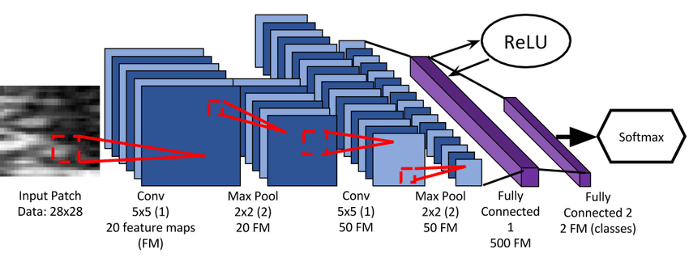
LeNet Architecture

CNN have a powerful architecture and they have solved a lot of machine learning tasks like detecting cancer, pneumonia etc. CNN train the weights from scratch and can easily fine tune them on the data and are very good feature extractor. The LeNet uses two connected convolutional layers and three fully connected layers. The model that we have used also uses 3 layers where the last layer is hidden layer. The shape of input dataset is (50, 50, 1) and the kernel have shape of 3, 5, 7. Kernels are basically filters that extract feature from the dataset. The activation function in the model are RELU and SOFT-MAX. RELU function is used in the convolutional layers and SOFT-MAX is generally used for multi-class classification but we have used it in the last i.e. hidden layers to differentiate between the COVID or NON-COVID patients. In the training phase the optimizer that we used is Adam optimizer which uses a standard stochastic gradient descent approach. The input layer/ first layer of the network has nothing to learn with and is used to take the input data. The official first layer of our network produces a matrix of 64 and has a kernel size of 3*3which are applied to the dataset and the max pooling is applied of 2*2 size. The next layers halves the dimension of the features and this process is called down sampling. After that the data is flattened and the activation function Relu is used, after that in the dense layer Soft-Max function is used to classify the images and very metrics for loss and accuracy are calculated like categorical-cross-entropy and accuracy metric for model performance. The whole model is built on Keras library and once the model is ready then it is tested on the test data for an epoch of 10 to get the final accuracy and validation scores. From the graphs we can conclude that the loss is decreasing on training and validation and the accuracy is increasing at nearly 8 epochs.

Result
Here we are going to discuss the results of the model. For that we have used the accuracy metric and achieved the best accuracy of 92 percent. The model is trained on a CNN network and then validated on the test dataset with an accuracy of 92%. From the visualization we can conclude that as the epochs are increasing the value of error is decreasing and our total accuracy is increasing and we got best accuracy at around 7th epoch. The dataset that we have uses has a total of 809 images out of which 538 images are positive and 271 images are negative and while getting the accuracy metric we have taken the test size of 10 percent. We can further increase the test size to 30 percent to compare the accuracy or what we can do is test this model on new dataset in the coming future to test the accuracy scores with the given dataset.

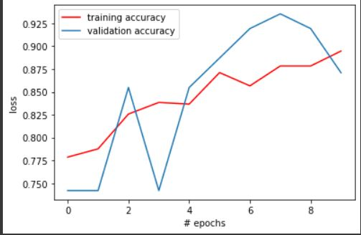

Discussion
In this experiment we have successfully taken the advantage of CNN based framework for the diagnosis of Covid-19 and for that we have taken the LeNet architecture and trained our model to save some time. In this algorithm we have taken the optimum value of activation functions, optimizers and epoch to get the best result and then we compared the results. Hence we have used deep learning algorithms in detecting the COVID cases .Moreover we achieved a very high accuracy and can further validate it on a future dataset and can use different techniques and models and can compare their accuracies to get the final best model. As we can see that the test data set has a size of 0.1 if we decrease the test size may be can further increase the accuracy. A lot of work has been done in this field and CNN based approaches were designed to detect the Covid-19 and some of the models obtained an accuracy around 80.6% for the classification of bacterial virus or Covid. The architectures like V-Net and ResNet-18 were used and the accuracy was around 86.7%. so if we look the overall performance of our model is perfectly fine.

Conclusion
In this report we have presented the study on the corona pandemic that has impacted the world in 2020 and still has its effect around the globe. The project has showed the deployment of convolutional neural network for the purpose of classification of Covid and no-Covid patient’s .As the corona virus cases are increasing on the daily basis, the demand for testing is also increasing. To tackle that problem we have used the power of machines and algorithms and with the high accuracy we can further test it on new dataset and on other architectures of CNN so that there should not be any case of over-fitting. For future we can expose this model to a larger positive and negative datasets and come with medical professionals to get the final output. And being a feasible method we can propose them to be implemented in the real case for their implementation.

References

- Khan Maseeh Shuaib, Solkar Ahmed Shahid, Ansari Almas Javed and Mohammed Zaid, "Pneumonia Detection through X-Ray Using Deep Learning", IOSR Journal of Computer Engineering (IOSR-JCE), vol. 22, no. 1, pp. 08-11.
- N Parveen and MM Sathik, "Detection of pneumonia in chest X-ray images", Journal of X-ray Science and Technology, vol. 1;19, no. 4, pp. 423-8, Jan 2011.
- Rajesh. Ranjan, "Predictions for COVID-19 outbreak in India using Epidemiological models", 2020.
- Yan L, Zhang HT, Xiao Y, Wang M, Sun C, Liang J, Li S, Zhang M, Guo Y, Xiao Y, Tang X (2020) Prediction of criticality in patients with severe Covid-19 infection using three clinical features: a machine learning-based prognostic model with clinical data in Wuhan. medRxiv.
- Hong, Z., Yun, Z. A Normalized Light CNN for Face Recognition. J. Phys. Conf. Ser. 2018, 1087, 062015. Doi.

